June 9, 2022

To Whom it May Concern:
Training Works is a Canadian knowledge and skills development company, experienced in identifying and resolving gaps in current skills, competencies, and knowledge infrastructure and then creating avenues for improvement and growth. In business for over seven years, we have a core leadership team with a combined over 50 years’ experience in workforce development along with a diversity of strategic partners and specialists to best serve our customers.

Over the past two years, Training Works has worked closely within Inuit communities and their community-based companies within the fishing industry to develop a strategic plan for skills development and a framework for mentorship development among indigenous employees. Qikiqtaaluk Corporation (QC) is a tremendous asset to the people of Nunavut and is involved at all levels of the community. Training Works is very proud to support QC-Fisheries Division in its application to the Future Skills Centre on skills development in Northern Canada. We are committed to working with QC to implement a program that will build capacity with a focus on skills development.

If you have any questions regarding the information outlined above, please do not hesitate to contact the undersigned.

Thank you and best regards,
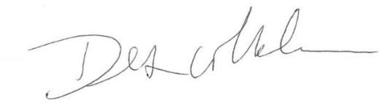

Des Whelan, Partner

PO Box 14141, Stn A Tel: (709) 743-5009
St. John’s, NL A1B 4G8 des@training-works.ca

